|  |  |
| --- | --- |
| Activity | Data Type |
| Number of beatings from Wife | Discrete Data |
| Results of rolling a dice | Discrete Data |
| Weight of a person | Continuous Data |
| Weight of Gold | Continuous Data |
| Distance between two places | Continuous Data |
| Length of a leaf | Continuous Data |
| Dog's weight | Continuous Data |
| Blue Color | Discrete Data |
| Number of kids | Discrete Data |
| Number of tickets in Indian railways | Discrete Data |
| Number of times married | Discrete Data |
| Gender (Male or Female) | Discrete Data |

Q1) Identify the Data type for the Following:

Q2) Identify the Data types, which were among the following

Nominal, Ordinal, Interval, Ratio.

|  |  |
| --- | --- |
| Data | Data Type |
| Gender | Nominal |
| High School Class Ranking | Nominal |
| Celsius Temperature | Interval |
| Weight | Ratio |
| Hair Color | Nominal |
| Socioeconomic Status | Interval |
| Fahrenheit Temperature | Interval |
| Height | Ratio |
| Type of living accommodation | Ordinal |
| Level of Agreement | Ordinal |
| IQ(Intelligence Scale) | Ratio |
| Sales Figures | Interval |
| Blood Group | Nominal |
| Time Of Day | Ratio |
| Time on a Clock with Hands | Ratio |
| Number of Children | Nominal |
| Religious Preference | Ratio |
| Barometer Pressure | Interval |
| SAT Scores | Ratio |
| Years of Education | Nominal |

Q3) Three Coins are tossed, find the probability that two heads and one tail are obtained?

* **Total possible outcomes ={HHH,HHT,HTH,THH,HTT,THT,TTH,TTT}**

**n (s) = 8**

**{HHT,HTH,THH}=3/8**

**Probability of two heads and one tail is 3/8.**

Q4) Two Dice are rolled, find the probability that sum is

1. Equal to 1
2. Less than or equal to 4
3. Sum is divisible by 2 and 3

* **Total possible outcomes={ (1,1),(1,2),(1,3),(1,4),(1,5),(1,6)**

**(2,1),(2,2),(2,3),(2,4),(2,5),(2,6)**

**(3,1),(3,2),(3,3),(3,4),(3,5),(3,6)**

**(4,1),(4,2),(4,3),(4,4),(4,5),(4,6)**

**(5,1),(5,2),(5,3),(5,4),(5,5),(5,6)**

**(6,1),(6,2),(6,3),(6,4),(6,5),(6,6)}**

**n (s) = 36**

1. **Probability =zero**
2. **n (s) = { (1,1),(1,2),(1,3),(2,1),(2,2),(3,1) }**

**Probability = 6/36 = 6**

1. **n(s) = {(1,1),(1,2),(1,3),(1,5),(2,1),(2,2),(2,4),(2,6),(3,1),(3,3),(3,5),(3,6)**

**(4,2),(4,4),(4,5),(4,6),(5,1),(5,3),(5,4),(5,5),(6,2),(6,3),(6,4),(6,6)}**

**Probability = 24/36**

Q5) A bag contains 2 red, 3 green and 2 blue balls. Two balls are drawn at random. What is the probability that none of the balls drawn is blue?

* **Total numbers of balls = 2+3+2 = 7**

**Total Case = 7c2 = 7!/2!*5! (! = Factorial)**

**= (7*6*5*4*3*2*1)/(2*1)*(5*4*3*2*1)**

**n (s) =21**

**Favourable Condition = 5c2 = 5!/2!*3!**

**= (5*4*3*2*1)/(2*1)*(3*2*1)**

**= 10**

**Probability = 10/21**

Q6) Calculate the Expected number of candies for a randomly selected child

Below are the probabilities of count of candies for children (ignoring the nature of the child-Generalized view)

|  |  |  |
| --- | --- | --- |
| CHILD | Candies count | Probability |
| A | 1 | 0.015 |
| B | 4 | 0.20 |
| C | 3 | 0.65 |
| D | 5 | 0.005 |
| E | 6 | 0.01 |
| F | 2 | 0.120 |

Child A – probability of having 1 candy = 0.015.

Child B – **probability of having 4 candies = 0.20**

* **Expected Number = summation (Candies Count*Probability)**

**=summation ((1*0.015)+(4*0.20)+(3*0.65)+(5*0.005)+(6*0.01)+(2*0.120))**

**= 3.09**

Q7) Calculate Mean, Median, Mode, Variance, Standard Deviation, Range & comment about the values / draw inferences, for the given dataset

* For Points,Score,Weigh>

Find Mean, Median, Mode, Variance, Standard Deviation, and Range and also Comment about the values/ Draw some inferences.

|  |  |  |  |
| --- | --- | --- | --- |
|  | Points | Score | Weigh |
| Mean | **3.59** | **3.21** | **17.84** |
| Median | **3.695** | **3.325** | **17.71** |
| Mode | **3.92** | **3.44** | **17.02** |
| Variance | **0.285** | **0.957** | **3.19** |
| Standard Deviation | **0.534** | **0.978** | **1.786** |
| Range | **2.17** | **3.911** | **8.4** |

|  |  |  |
| --- | --- | --- |
|  |  |  |

**Use Q7.csv file**

Q8) Calculate Expected Value for the problem below

1. The weights (X) of patients at a clinic (in pounds), are

108, 110, 123, 134, 135, 145, 167, 187, 199

Assume one of the patients is chosen at random. What is the Expected Value of the Weight of that patient?

* **Expected Value = Sum{X*Probability(X)}**

**=Sum{(108*1/9),(110*1/9),(123*1/9),(134*1/9),(135*1/9),(145*1/9),(167*1/9),(187*1/9),(199*1/9)}**

**= 130.33**

**Q9)** Calculate Skewness, Kurtosis & draw inferences on the following data

Cars speed and distance

Use Q9_a.csv

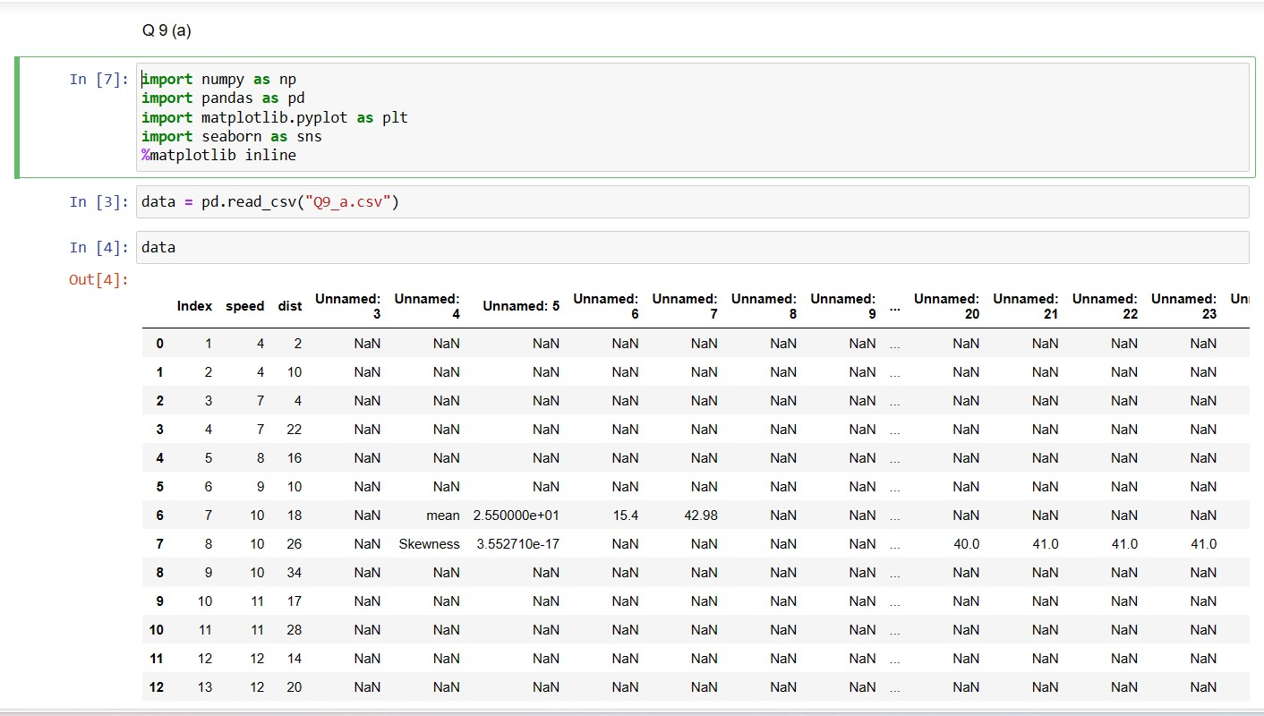

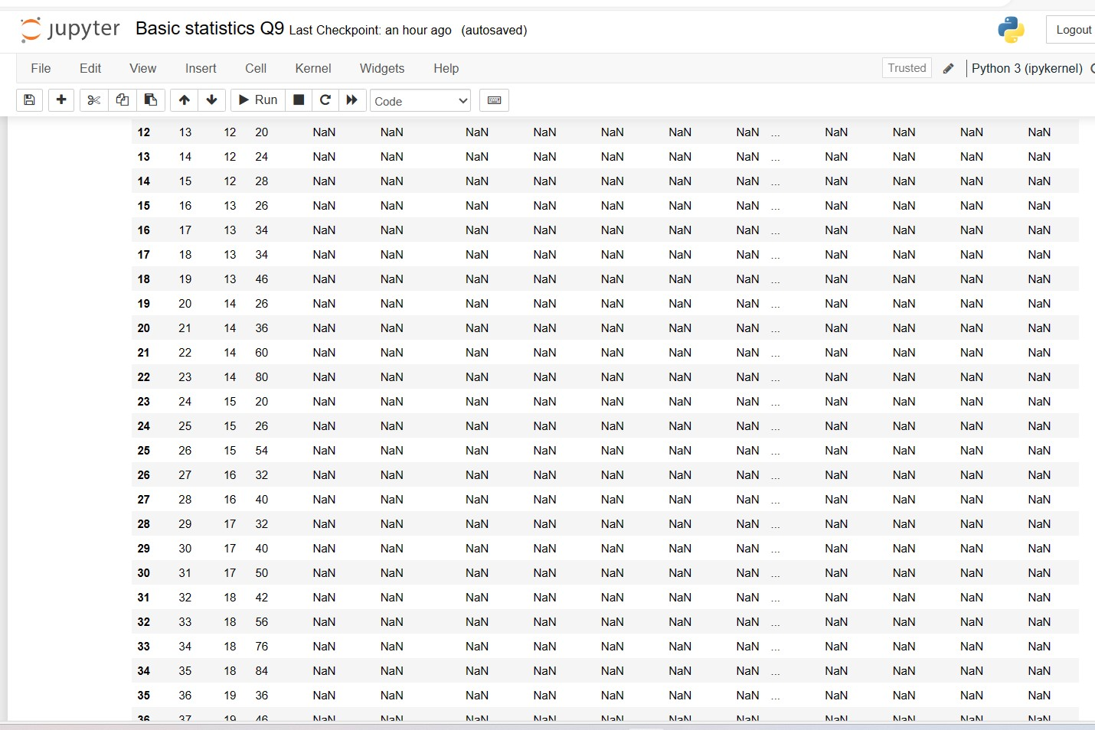

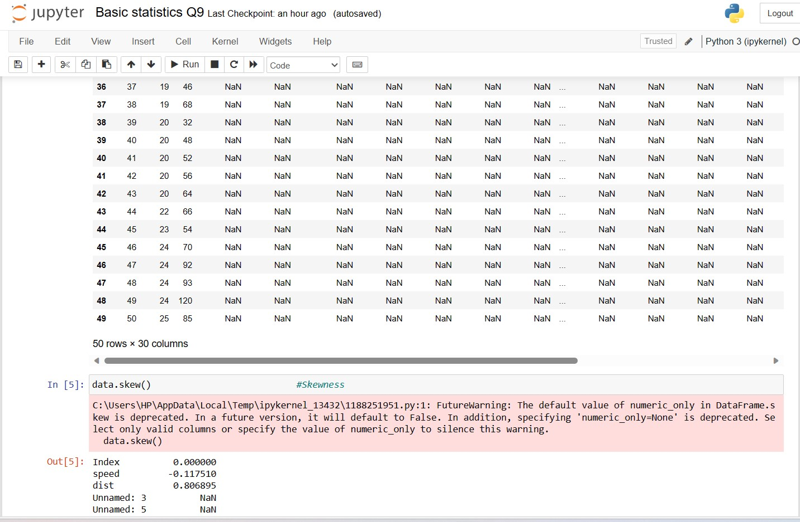

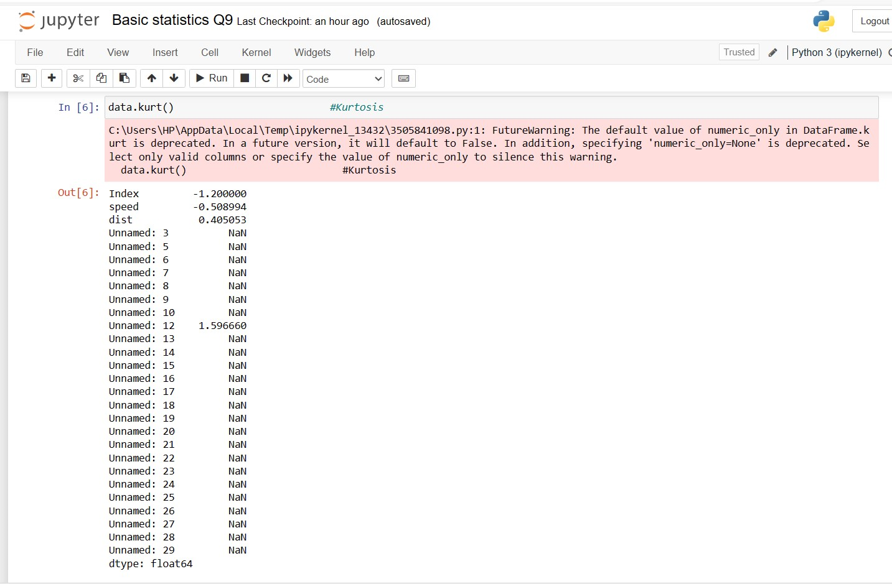

**SP and Weight(WT)**

**Use Q9_b.csv**

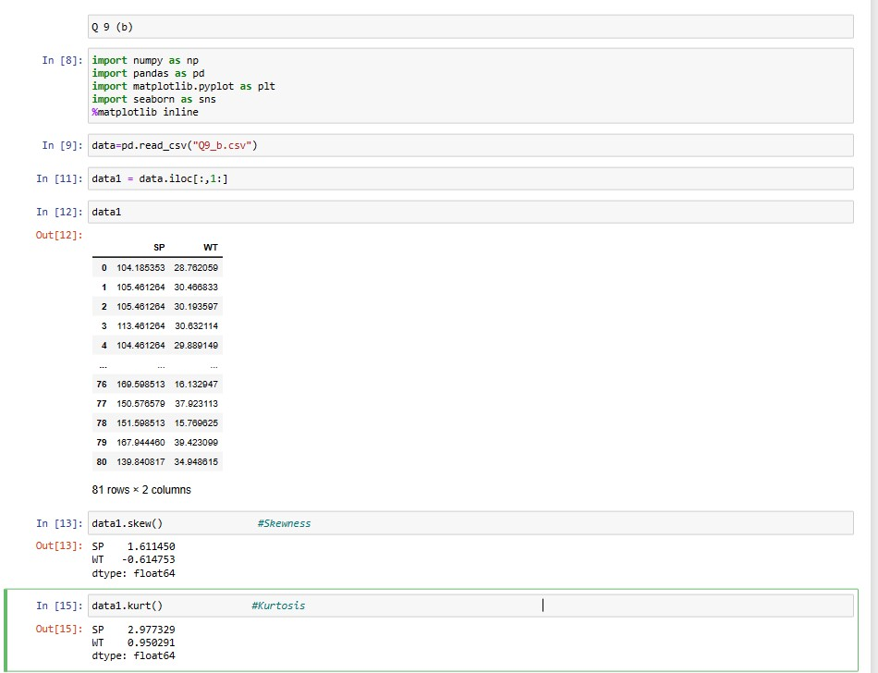

**Q10) Draw inferences about the following boxplot & histogram**

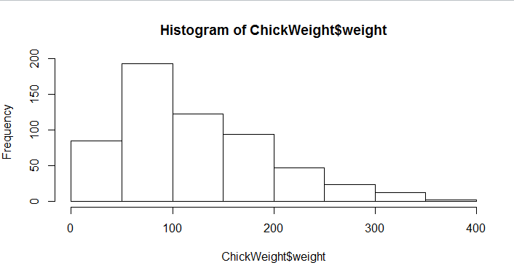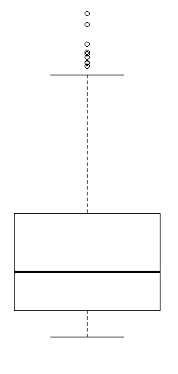

* **The histogram pick has right skew and tail is one right. Mean>Media .We have outlier on the higher side.**

**The boxplot has outliers on the maximum side.**

**HISTOGRAM INTERPRETATION – 1. Here we have 8 classes . here each class width is 50 . here the data is distributed more o the right side which make it positively skewed . here we have outlier from 300 to 400 as it lies in the tail region of a histogram.**

**BOXPLOT INTERPRETATION - here we have median which lies near to 1st quartile range / lower quartile .here it is right skewed because median lies near to lower quartile . here we have outliers above the upper extreme**

**Q11)** Suppose we want to estimate the average weight of an adult male in Mexico. We draw a random sample of 2,000 men from a population of 3,000,000 men and weigh them. We find that the average person in our sample weighs 200 pounds, and the standard deviation of the sample is 30 pounds. Calculate 94%,98%,96% confidence interval?

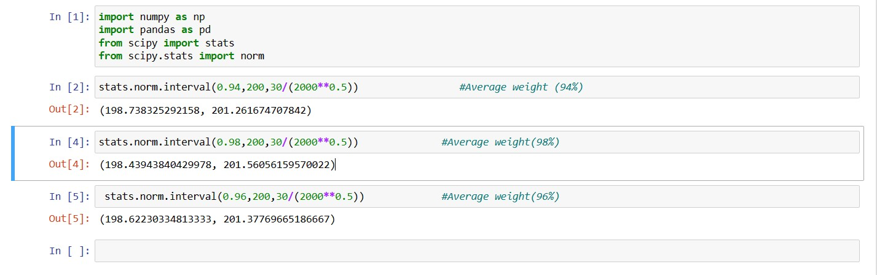

**Q12)** Below are the scores obtained by a student in tests

**34,36,36,38,38,39,39,40,40,41,41,41,41,42,42,45,49,56**

1. Find mean, median, variance, standard deviation.
2. What can we say about the student marks?



|  |  |  |  |
| --- | --- | --- | --- |
| Mean | Median | Variance | Standard Deviation |
| 41 | 40.5 | 25.52 | 5.052 |

* **We don’t have an outliers & the data is slightly skewed towards right because mean is greater than median.**

Q13) What is the nature of skewness when mean, median of data are equal

**When the value of mean , median , are equal then there is no skewness. . which**

**Is 0 skewness**.

Q14) What is the nature of skewness when mean > median

**When the mean is greater than the median it means it is positively skewed ./ right skewed**

Q15) What is the nature of skewness when median > mean?

**When the median is greater than the mean it means it is negatively skewed./ left skewed**

Q16) What does positive kurtosis value indicates for a data ?

**It indicates heavier tails and a more peaked distribution .here the values are located more in the tail of the distribution rather than mean**

Q17) What does negative kurtosis value indicates for a data?

:-**it indicates the lighter tails and a flatter distribution .**

Q18) Answer the below questions using the below boxplot visualization.

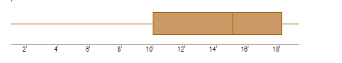

What can we say about the distribution of the data?

**The median value is between 14 to 16, here q1 is 10 and q3 is 18 . min value is <2 and maximum value is >18 . the distribution is negatively skewed as the median is located near to the right of center of the box.**

What is nature of skewness of the data?

**Here the median is near to the upper whisker and lower whisker is long as compare to upper whisker which indicate the skewness is NEGATIVE.**

What will be the IQR of the data (approximately)?

**:-Q1 = 10  
Q3 = 18  
median = 14+16/2= 15**

**Q2 = 15.**

**Interquartile range = Q3-Q1**

**= 18-10=8**

Q19) Comment on the below Boxplot visualizations?

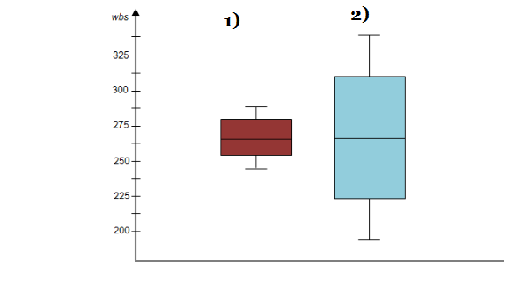

Draw an Inference from the distribution of data for Boxplot 1 with respect Boxplot 2.

* **First there are no outliers. Second both the box plot shares the same median that is approximately in a range between 275 to 250 and they are normally distributed with zero to no skewness neither at the minimum or maximum whisker range. here the median for both the boxplot is same i.e 262.5 here the boxplot 2 has the large interquatile range as compare to boxplot 1 , here the min and max values for boxplot 2 is more than boxplot 1 . the boxplot 2 has larger value of Q1 and Q2 Compare to boxplot 1**

Q 20) Calculate probability from the given dataset for the below cases

Data _set: Cars.csv

Calculate the probability of MPG of Cars for the below cases.

MPG <- Cars$MPG

* 1. P(MPG>38) =
  2. P(MPG<40)
  3. P (20<MPG<50)

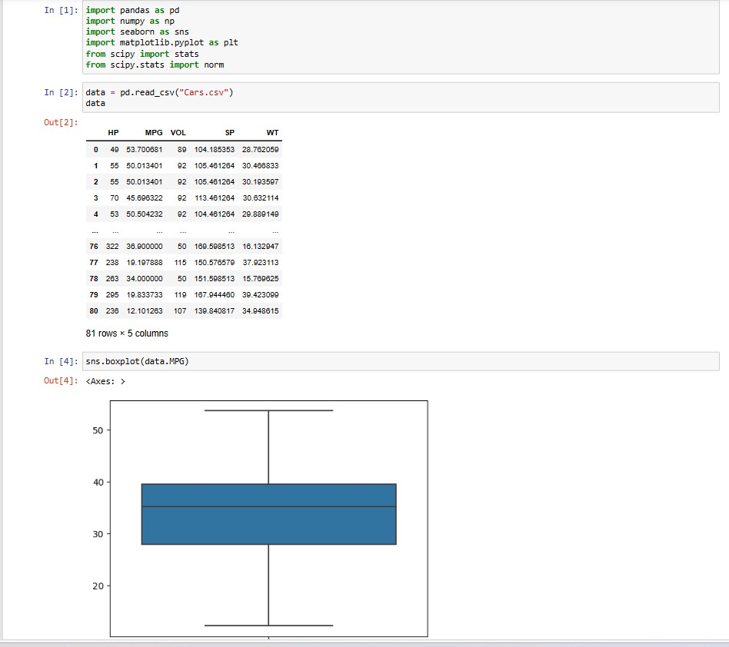

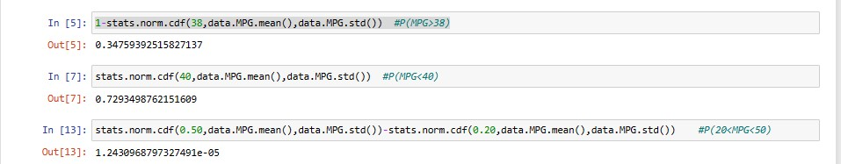

Q 21) Check whether the data follows normal distribution

1. Check whether the MPG of Cars follows Normal Distribution

Dataset: Cars.csv

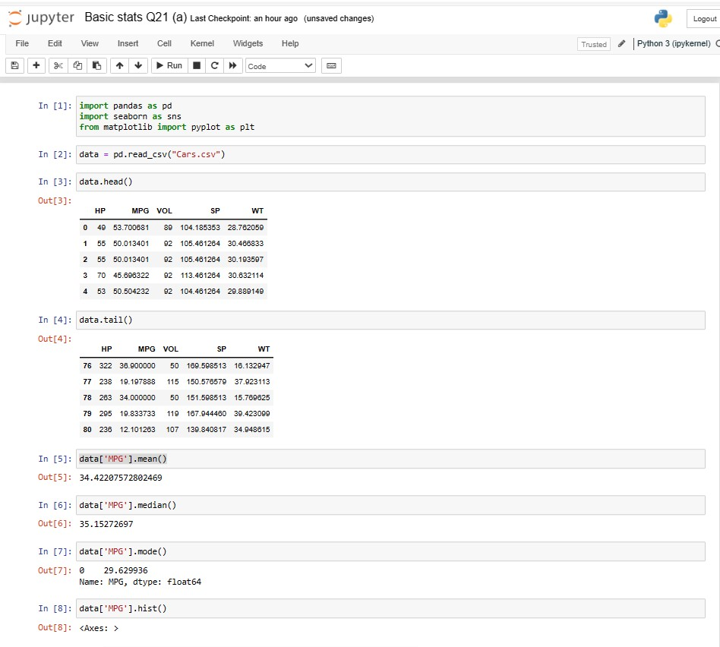

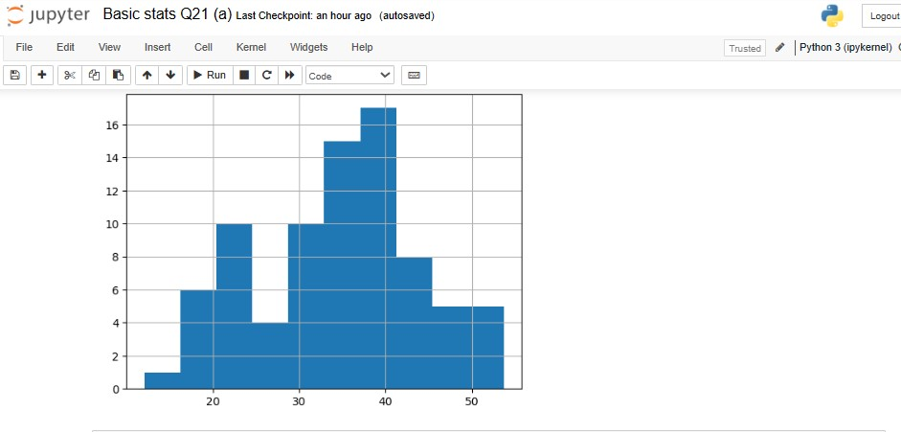

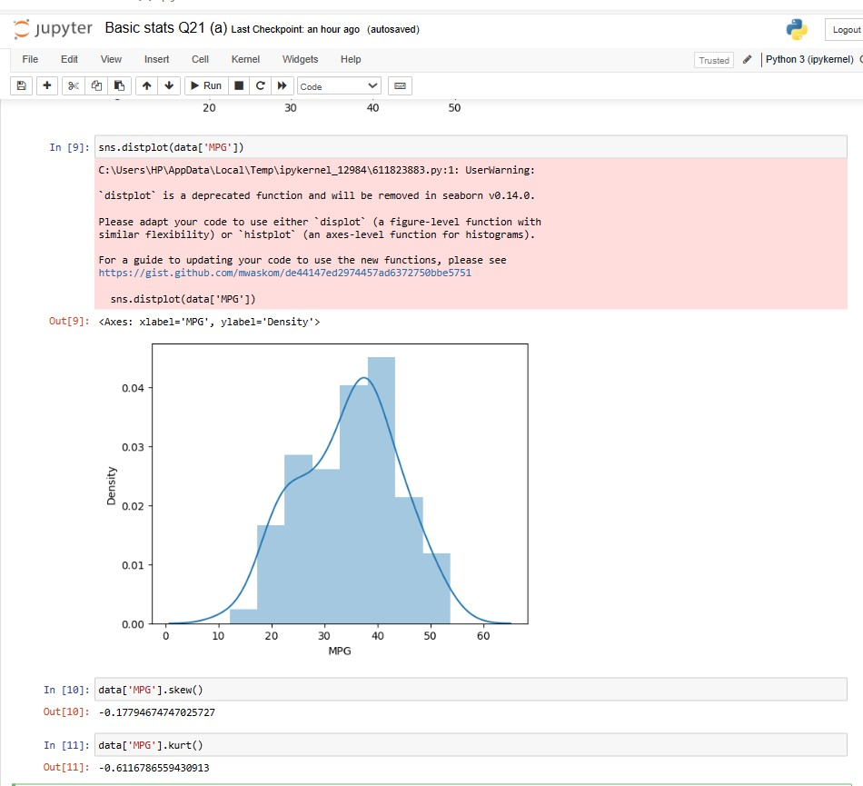

1. Check Whether the Adipose Tissue (AT) and Waist Circumference(Waist) from wc-at data set follows Normal Distribution

Dataset: wc-at.csv



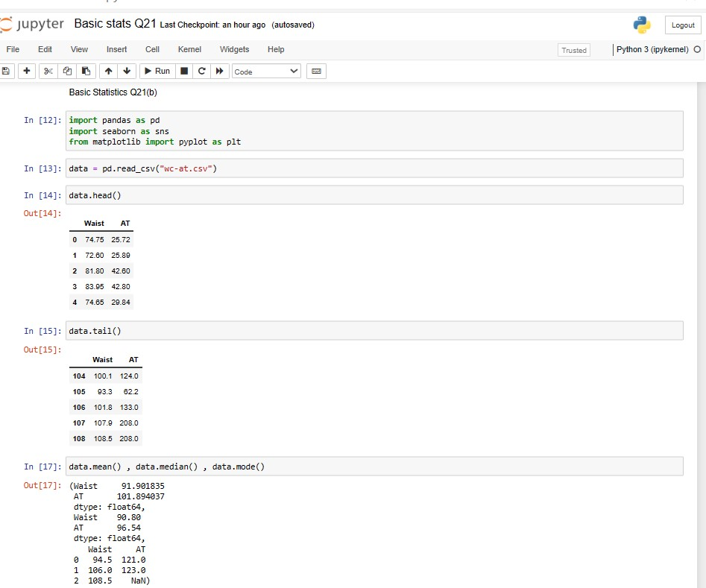

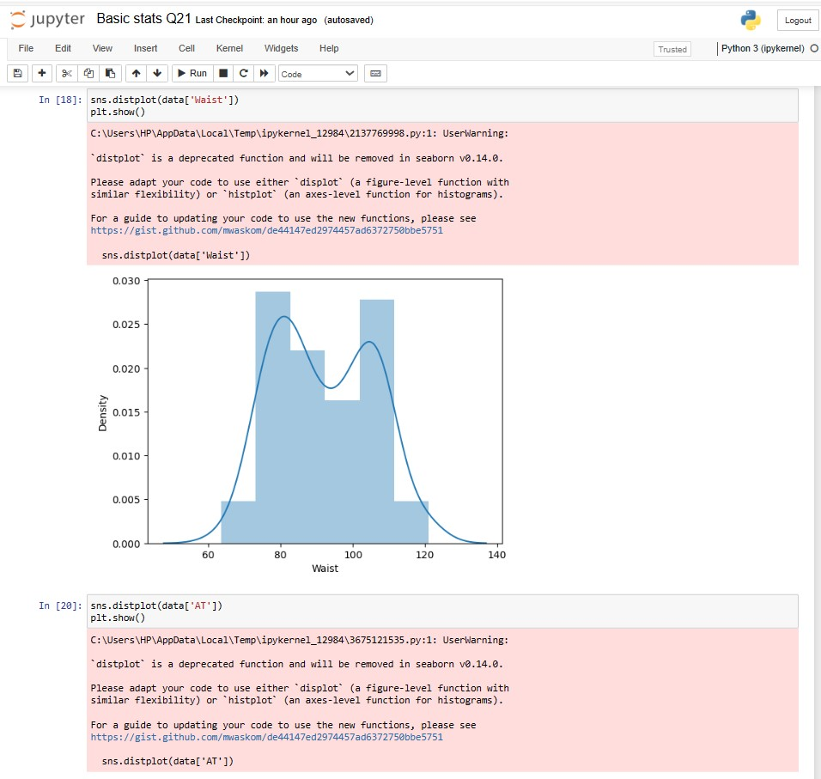

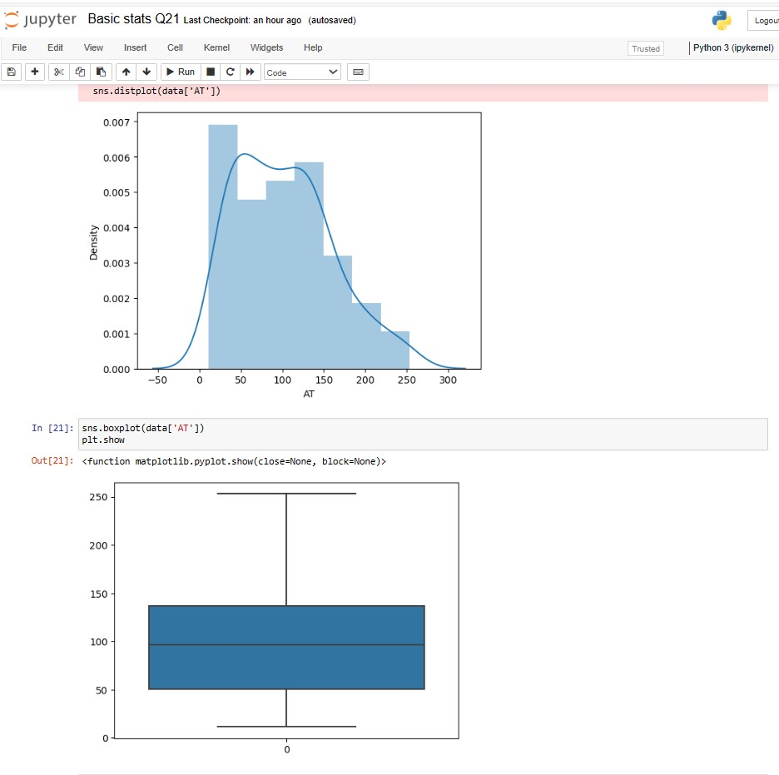

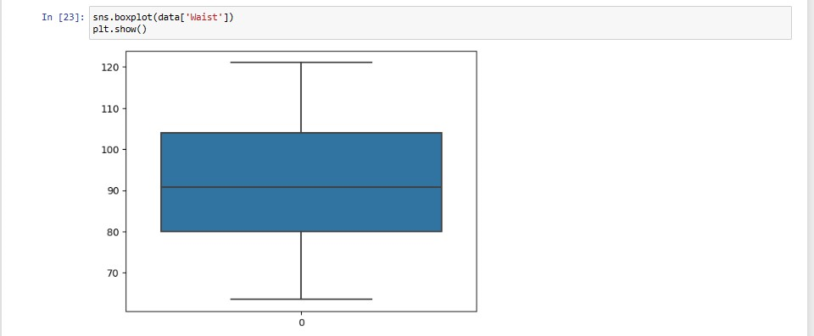

Q 22) Calculate the Z scores of 90% confidence interval,94% confidence interval, 60% confidence interval



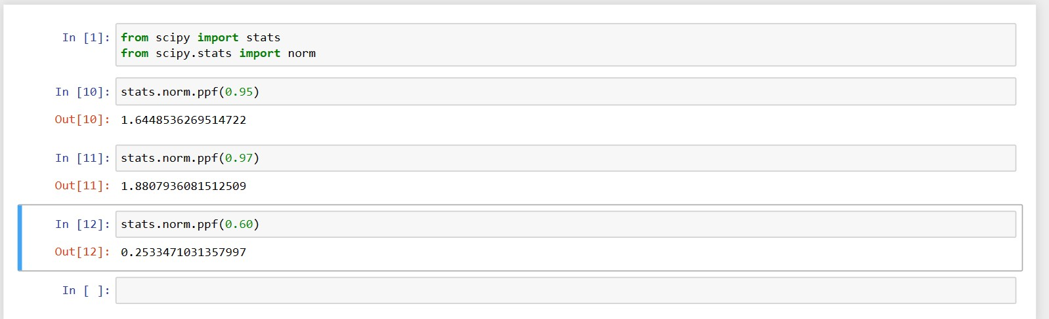

:- for 90% confidence interval : we have the significance level at 5%( as it is a two tailed test)

a = 5%=0.05

z at a = 0.05 from the z table will be **z=1645**.

:-for 94% confidence interval : we have the significance level at 3% ( as it I is two tailed test)

a = 3%= 0.03

z at a = 0.03 from the z table will be **z = 1.555**

:-for 60% confidence interval : we have the significance level at 20%( as it is two tailed test)

a = 20% = 0.2

z at a = 0.2 from the z table will be **z= 0.253**

**Therefore we get z score at 90%=1.645**

**At 94% = 1.555**

**At 60% = 0.253**

Q 23) Calculate the t scores of 95% confidence interval, 96% confidence interval, 99% confidence interval for sample size of 25



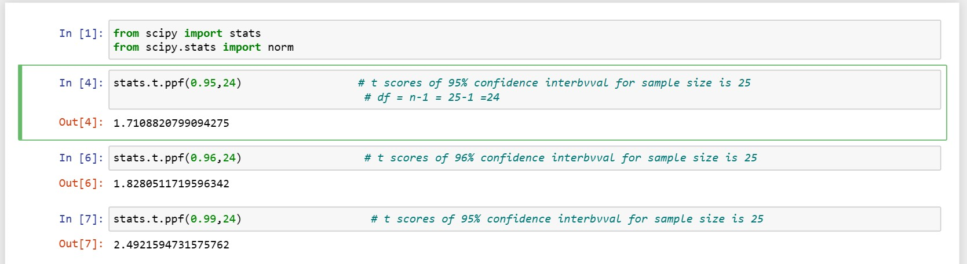

Q 24**)** A Government company claims that an average light bulb lasts 270 days. A researcher randomly selects 18 bulbs for testing. The sampled bulbs last an average of 260 days, with a standard deviation of 90 days. If the CEO's claim were true, what is the probability that 18 randomly selected bulbs would have an average life of no more than 260 days

Hint:

rcode 🡪 pt(tscore,df)

df 🡪 degrees of freedom

* **n = 18 , x bar = 260 , s = 90 , µ = 270**

**df = n-1 = 17**

**t = x bar - µ /(s/ root n) = (260-270)/(90/root18) = -0.471**

**P(t≤-0.471) = 0.321 (Using t distribution calculator and python)**

**There is a 32.1% chance that 18 randomly selected bulbs would have an average life of no more than 260 days .**